Project Development Phase
Model Performance Test

Date | 08 October 2026
Team ID | 9100RootAccess
Project Name | Auto Ticket Classification using ServiceNow Flow Designer
Maximum Marks

Model Performance Testing:
Project team shall fill the following information in model performance testing template.
S.No. | Parameter | Values | Screenshot
 | Model Summary | No AI / ML model is used. Classification is done by a rule-based, no-code ServiceNow Flow Designer flow (If / Else If conditions on the Short description: Wi-Fi or Network → Network / Wi-Fi; Projector → Hardware / Projector; Forgot password → Access / Forgot Password; Slow computer → Performance / Slow Computer). | 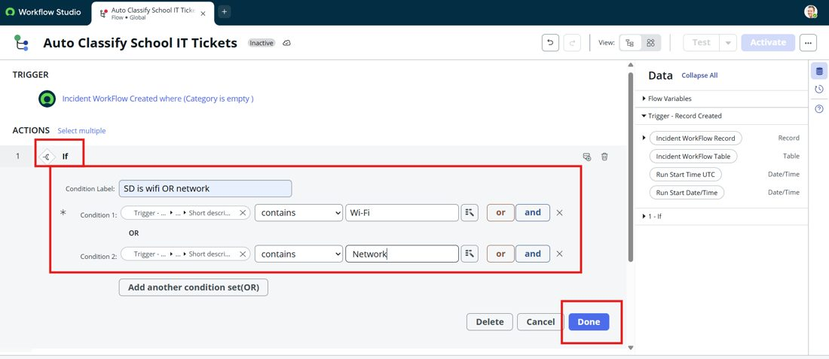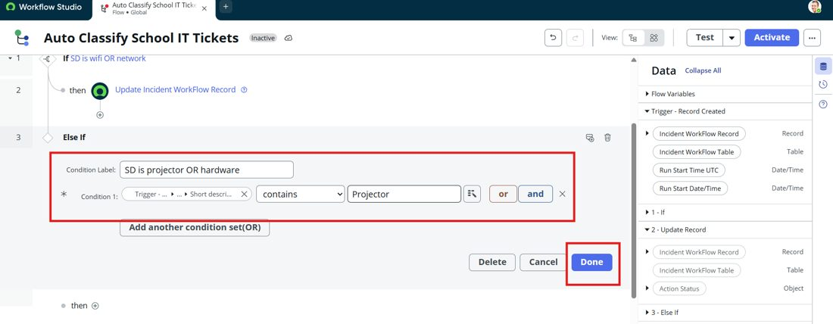
 | Accuracy | Training Accuracy – Not applicable (rule-based)  Validation Accuracy – 100% on executed test scenarios (2 of 2) | 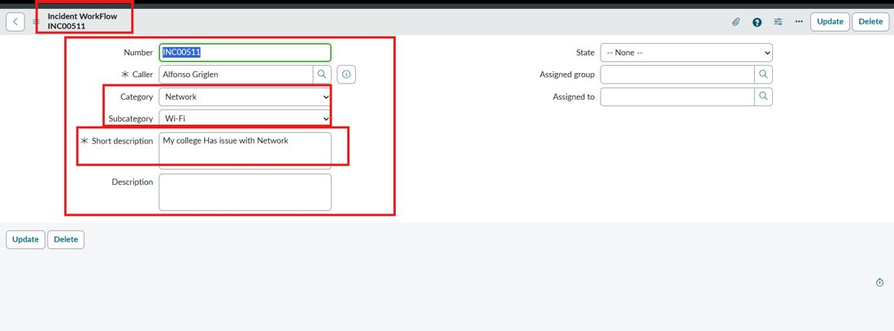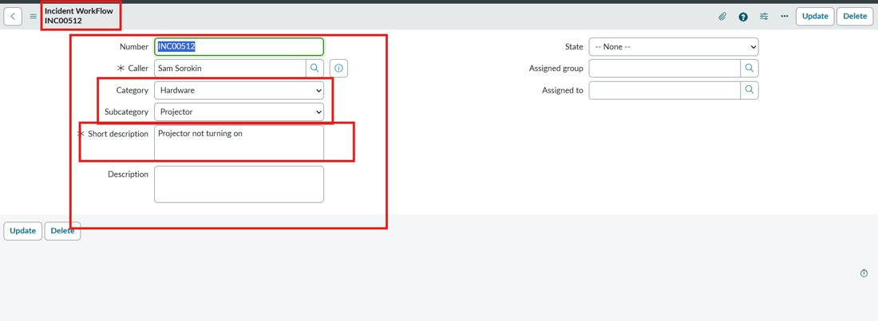
3. | Fine Tunning Result( if Done) | Validation Accuracy – Not applicable (no model tuning). Possible future improvement: add more keywords and use Predictive Intelligence for classification.

